**Construtor in Inheritance**

1. Write a program with parent and child class with constructor in both parent and child class . Create the object for child class and check which constructor is called.

class **parent**:

def **__init__**(*self*):

print(*"parent"*)

class **child**(parent):

def **__init__**(*self*):

print(*"Child"*)

ob=child()

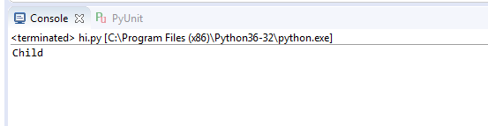

1. Write a program with parent and child class with constructor in parent class . Create the object for child class and check which constructor is called.

class **parent**:

def **__init__**(*self*):

print(*"parent"*)

class **child**(parent):

def **display**(*self*):

print(*"child"*)

ob=child()

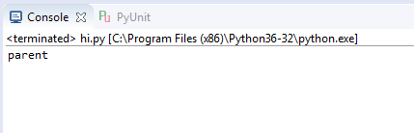

1. Write a program with parent and child class with parameterized constructor in parent class . Create the object for child class (with out any parameter) and check which constructor is called.

class **parent**:

def **__init__**(*self*,a,b):

print(*"parent"*,*self*.a,*self*.b)

class **child**(parent):

def **__init__**(*self*):

print(*"Child"*)

ob=child()

